**"CFRPM Model Description Outline March2016.DOCX”**

**First Document Reviewed for inclusion in CFRPM Model Description Outline - (1.) "Tech Memo - CFRPM Trip Generation 12-23-15 w_o STP60 write-up_comments.DOC"**

**Findings - This report can be useful:**

* **As a legacy summary of trip generation values.**

There is no need to include any of this report in the CFRPM Model Description Outline and follow-on report. The report compares trip generation production and attraction rates from many sources. The historical comparisons and values have been superseded by the very recent trip generation values provided in the Tallahassee Prototype Model[1]. This FSUTMS structure uses the 2009 National Household Travel Survey (NHTS) Florida records + add-on when no local household survey is available. This is what CFRPM needs to do.

**Trip Production**

The Tallahassee Prototype Model described in this FSUTMS provides a well-researched set of trip production cross classification tables. Once used in the model, the source of the rates can be sourced as 2009 NHTS + Add-On.

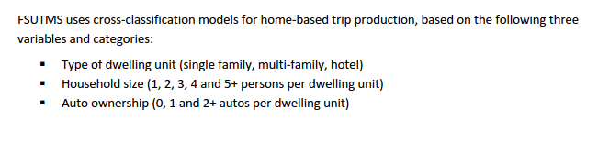

Figure 1: Trip**_Generation_Review_and_Recommended_Improvements.pdf, page 4**

Within an MPO model extent, it is not acceptable to have trip generation rates that change from county to county. This uniformity of trip generation rates across a model extent is one of the rules of travel demand forecasting. Neither the "lifestyle" nor the area type trip generation dimension can be recommended for CFRPM.

**Trip Attraction**

Standard linear regression models were estimated for all of Florida for the Tallahassee Prototype Model. These values can be asserted in the CFRPM trip attraction model.

**Second Document Reviewed for inclusion in CFRPM Model Description Outline - (2.) "Tech Memo - CFRPM Zone Consistency DRAFT 3-25-16.DOC"**

**Findings**

* **Once updated to the current base and future years, parts of this report may be useful as Appendices. In some MPOs, the agency maintains an internal Working Paper library, sometimes on a wiki, to share this type of analysis and make it easier to conduct review during the next cycle.**
* Population-to-Employment Ratio - Population-to-employment ratios usually do not need to be consistent. Many zones have only population (pure residential) and others mainly employers.
* Growth Patterns, Review of Development at County Boundaries and TAZ Area Analysis – These topics belong in Appendices. The appendices for the final methodology and validation are still under review.

1. http://www.fsutmsonline.net/images/uploads/reports/Trip_Generation_Review_and_Recommended_Improvements.pdf